To: Springdale Estates Association Board

From: Mark Connolly, Van Cotter and Don Neal

8 January 2021

Proposal to add Beneficial Aquatic and Shoreline Plants to and along Lower Springdale Estates Lake

Background: One recommendation from Solitude Lake Management to improve the quality of Lower Springdale Estates Lake is to add beneficial aquatic plants (Report of 17 Nov 20 and Teleconference of 16 Dec 20). They specifically recommended duck potato, pickerel weed, and Virginia iris (southern blue flag).

To that end, we make the following proposal and request support to add beneficial aquatic plants to Lower Springdale Estates Lake for shallow water areas and along the shoreline buffer. The estimated cost would be circa $250 which we suggest could be covered by using money budgeted for landscaping the dam. In addition, we can provide some plants without cost. We would provide the manpower to plant all of the plants pro bono.

The Springdale Estates Garden Club discussed this proposal and support it. We have revised the proposal based on suggestions from the Garden Club. One suggestion was to start with 10 plants and 2 ferns (see table).

Benefits that these plants would provide:
- Improving water quality.
  - Removing nutrients (N and P) from the water and sediment making them unavailable for blue-green blooms.
  - Stabilizing shoreline and helping control erosion by creating a shoreline planting buffer to intercept runoff from yards. The buffer is intended to slow the movement of storm water to give sediment a chance to drop out before it reaches the lake. This can reduce sediment flow and nutrient flow (N and P) into the lake. Reducing nutrient load coming into the lake is important for reducing blue-green growth.
- Increasing the food base and reproductive habitat for aquatic animals.
- Providing shelter and food for forage fish, in turn providing food for predatory fish such as largemouth bass.
- Providing shade for fish during warm sunny days.
- Increasing the dissolved oxygen level lessening the potential for fish die-offs.
- Improving the beauty of the Lake with greenery and beautiful flowers.
- Providing food for bees, birds and butterflies.

All proposed plants are native herbaceous perennials. Final selection of plants would be made considering plant attributes, availability, cost and suitability for our Lake.

Included in this request would be the purchase of additional plants for Upper Springdale Estates Lake because improving the water quality of the Upper Lake in turn benefits the Lower Lake and the cost is minimal.

Planting can be done any time of the year, but best would be March through September. We propose starting plantings in March.

One concern is whether water fowl and other animals would consume the new plantings. We may need to protect newly planted plants with cages.

Proposed beneficial aquatic plants for Springdale Estates Lakes
Plants are listed in three categories, shallow water emergent, shoreline and deep pond floating. Withing each category, plants are listed alphabetically be common name.
See Appendix for pictures of the plants.

Plant |  | Number | Cost | Source | Comments | Habitat | Sun/Shade
Arrow arum  (Peltandra virginica) | Plants |  | Free | Lynn Smiley | Arrow-shaped leaves | Shallow water emergent | Sun
Creeping rush  (Juncus repens)  or Juncus effusus |  | Plants | ? | ? | Attractive green foliage | Shallow water emergent | Sun
Duck Potato  (Sagittaria latifolia) |  | 40 plugs | $40 | Mellow Marsh Farm | Edible tubers. | Shallow water emergent | Sun
Lizard’s Tail  (Saururus cernuus) |  | Rhizomes | Free | Divide plants existing in Lower Lake transplanting rhizomes | Arched tail shaped white flowers (bottle-brush). Supports butterflies. Many in Lower Lake, could be added to Upper Lake. | Shallow water emergent | Partial Sun
Pickerelweed  (Pontederia cordata) |  | 40 plugs | $40 | Mellow Marsh Farm, also available in 4” ($2.75) and gallon pots | Spikes of purple flowers. Source of pollen for bees. Can be aggressive. | Shallow water emergent | Sun
Cinnamon Ferm  (Osmunda cinnamonmea) |  | Plants | ? | ? | Deer resistant | Shoreline edge | Tolerates shade
Gray sedge  (Carex grayi) |  | Seeds / Seedlings | Free | Cotters | Attractive seed heads | Shoreline | Tolerates partial shade and some wet soil
Marsh Fern  (Thelupteris palustris) |  | Plants | ? | ? | Deer resistant | Shoreline | Tolerates partial shade
River Oats  (Chasmanthium latifolium) |  | Seeds / Seedlings | Free | Cotters, MacDougals | Attractive dangling seed heads. Songbirds eat seeds. | Shoreline | Shade tolerant
Swamp milkweed  (Asclepias incarnata) |  | Seeds / Seedlings | ? | ? | Good for butterflies | Shoreline | Sun
Virginia Iris  (Iris virginica) |  | 40 plugs | $40 | Mellow Marsh Farm | Slightly fragrant, showy violet flowers. | Shoreline | Sun
American Lotus  (Nelumbo lutea) |  | ? | ? | ? | Showy white to pale yellow flowers. Edible seeds. | Deep pool floating | Flowers best in sun

Additional species to consider in the future:
Shoreline
Mud Plantain Heteranthera spp.
Sweet Flag Acorus calamus – aggressiveness a concern
Water Plantain Alisma triviale
Burhead Echinodorus berteroi
Netted Chain Fern Woodwardia arealata
Emergent
Spike Rushes Eleocharis spp.
Soft Rush Juncus effusus $2 per large plug, Mellow Marsh
Arrowheads Sagittaria spp
.

Schoenoplectus sp.

Sparganium americanum
There are a number of sedges in the genus Carex that are quite nice for dry to very wet areas in shade to full sun.
Bacopa caroliniana (bacopa)
Cabomba caroliniana (Cabomba or fanwort)
Ceratophyllum demersum (coontail)
Najas guadalupensis (southern naiad)
Nymphoides aquatica (banana lily)
Potamogeton diversifolius (waterthread pondweed)
Vallisneria americana (tape grass or eel grass)

Appendix A. Planting Plan

Planting Locations

Two habitats will be planted, shallow water and the shoreline buffer; at any given location plants will be added to one or both habitats..
- Lower Springdale Estates Lake
  - Selected places along the dam
  - At the margins of the dam
  - At the two locations where the power line crosses
  - In the deltas where streams enter
  - Potentially additional sites in the shoreline buffer
- Upper Springdale Estates Lake
  - Inlet area after dredging
  - Selected places along the dam

Additional planting areas may be identified.

A planting map will be developed.

Appendix B. Photos of the Plants

Photo Credits: Wikipedia.

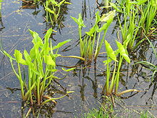
Arrow arum (Peltandra virginica)

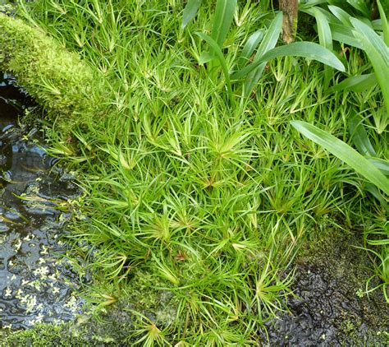
Creeping rush (Juncus repens)

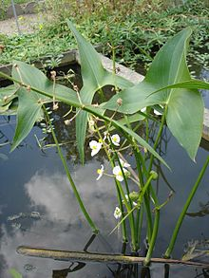
Duck Potato (Sagittaria latifolia)

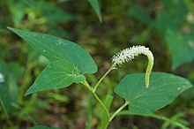
Lizard’s Tail (Saururus cernuus)

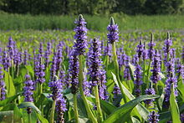
Pickerelweed (Pontederia cordata)

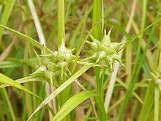
Gray sedge (Carex grayi)

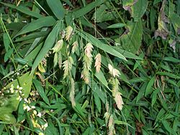
River Oats (Chasmanthium latifolium)

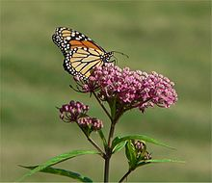
Swamp milkweed (Asclepias incarnata)

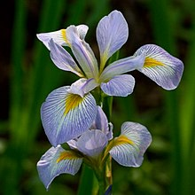
Virginia Iris (Iris virginica)

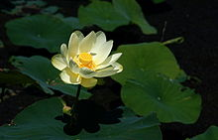
American Lotus (Nelumbo lutea)

